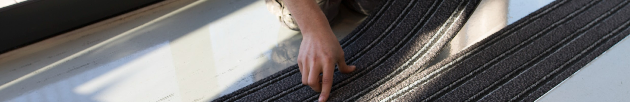
QUICKMAT-TILE
ARCHITECT DESCRIPTION // QUICKMAT-TILE

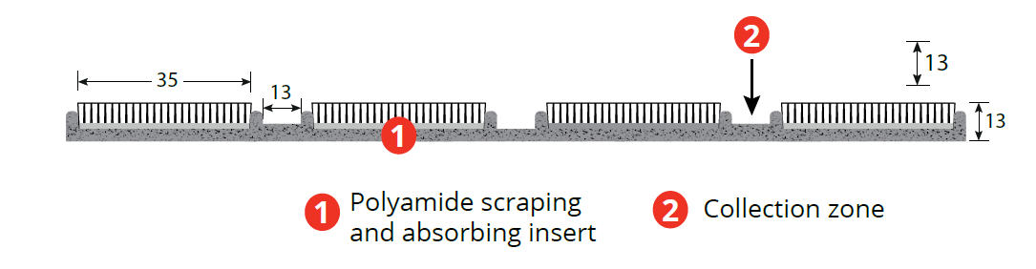
AS ISO 9239-1-2013

4.3 L/m2
33

IND
Medium
(100kg)
Area 2

Architect description:

Supply of ROMUS brand QUICKMAT-TILE modular entrance matting for installation in a recess. Positioned in indoor entry areas, they will be dimensioned with a (minimum) walking length of 3m to absorb at least 70% of dirt and moisture

Strong and wheel-chair accessible, constructed on a latex backing, QUICKMAT-TILE mats will be AS ISO 9239-1-2013 fire when stuck down, made of scraping, absorbent and anti-slip textile inserts as well as collection areas. 80% of the surface area will be polyamide 6.6 fibres, and 20% polypropylene fibres.

Delivered in planks 23.5 x 75cm sections with a weight of 5.7 kg per m2, a slip resistance P4, the mat thickness will be 13 mm, absorption capacity 4.3 litres / m2, and the colours of the inserts will be anthracite, Ref. E555 0001

Installation will take place in a 13mm recess using an installation frame, Ref 6113, or 11 mm "L" frame, Ref. 6099/6082, or a self-adhesive frame Ref. 6290.

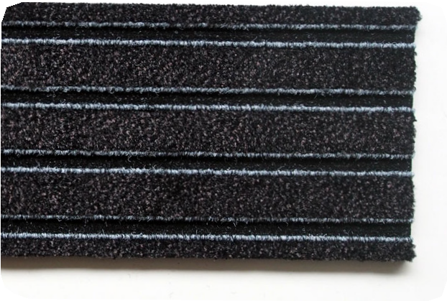
Anthracite

